**IS 306 Data Management Communications and Networking**

**HOP06A – Installing Wireshark on MacOS**

12/26/2019 Developed by Clark Ngo

Center for Information Assurance (CIAE) @City University of Seattle (CityU)



**Before You Start**

* Version numbers may not match with the most current version at the time of writing. If given the option to choose between stable release (long-term support) or most recent, please choose the stable release rather than beta-testing version.
* This tutorial targets Windows users and MacOS users.
* There might be subtle discrepancies along the steps. Please use your best judgement while going through this cookbook style tutorial to complete each step.
* For your working directory, use your course number. This tutorial may use a different course number as an example.
* The directory path shown in screenshots may be different from yours.
* If you are not sure what to do or confused with any steps:
  1. Consult the resources listed below.
  2. If you cannot solve the problem after a few tries, ask a TA for help.

**Learning Outcomes**

Students will be able to:

* Installing and using Wireshark

**Resources**

* Wireshark - <https://www.wireshark.org/>

**Installing Wireshark**

**Create a Wireshark website:**

1. Go to <https://www.wireshark.org/download.html>
2. Choose macOS

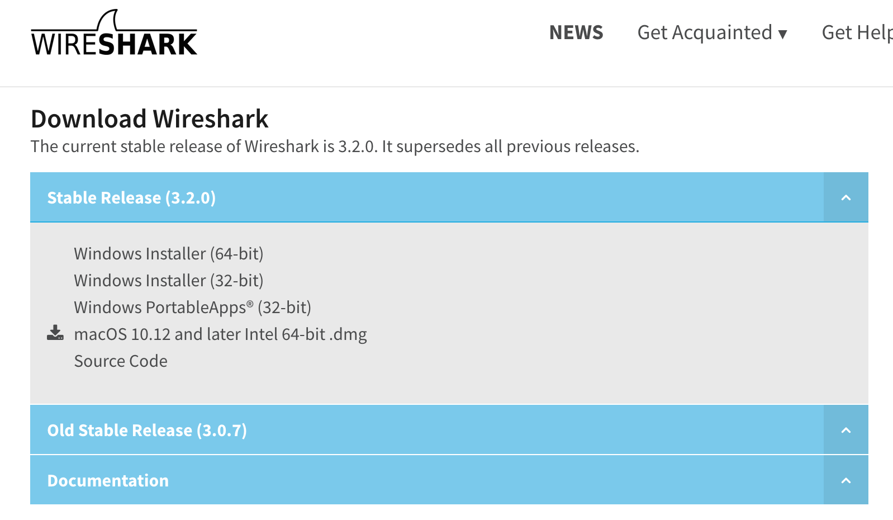

1. Open the downloaded file

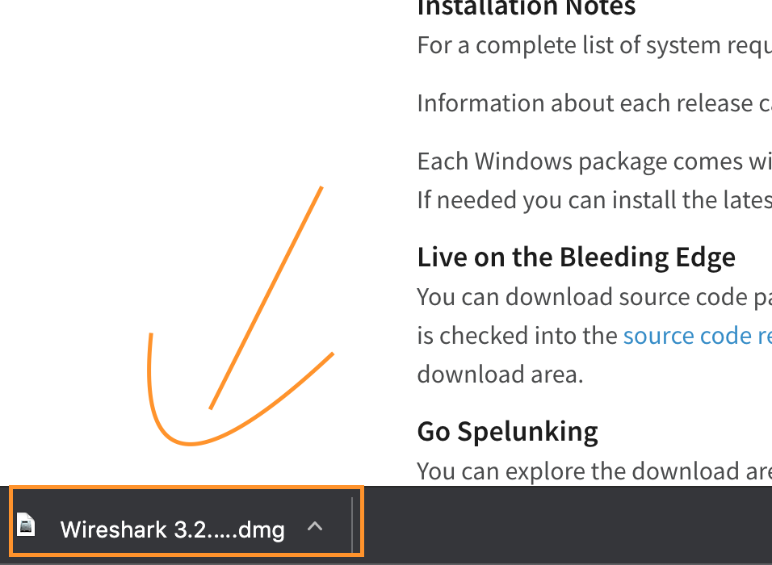

1. Drag the Wireshark to Applications

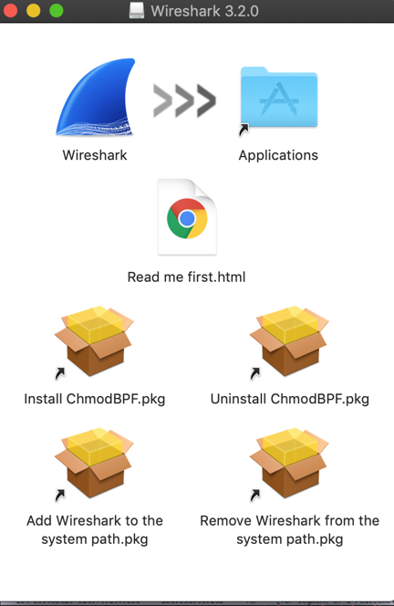

1. Allow Wireshark app

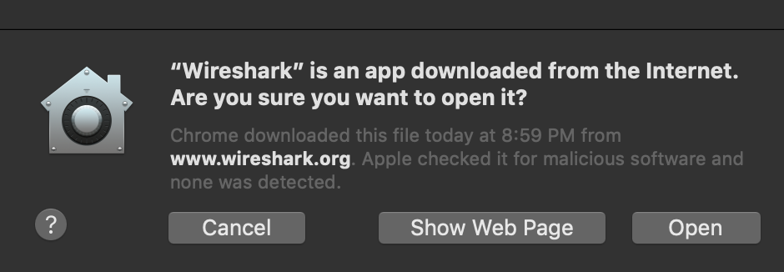

1. Install ChmodBPF

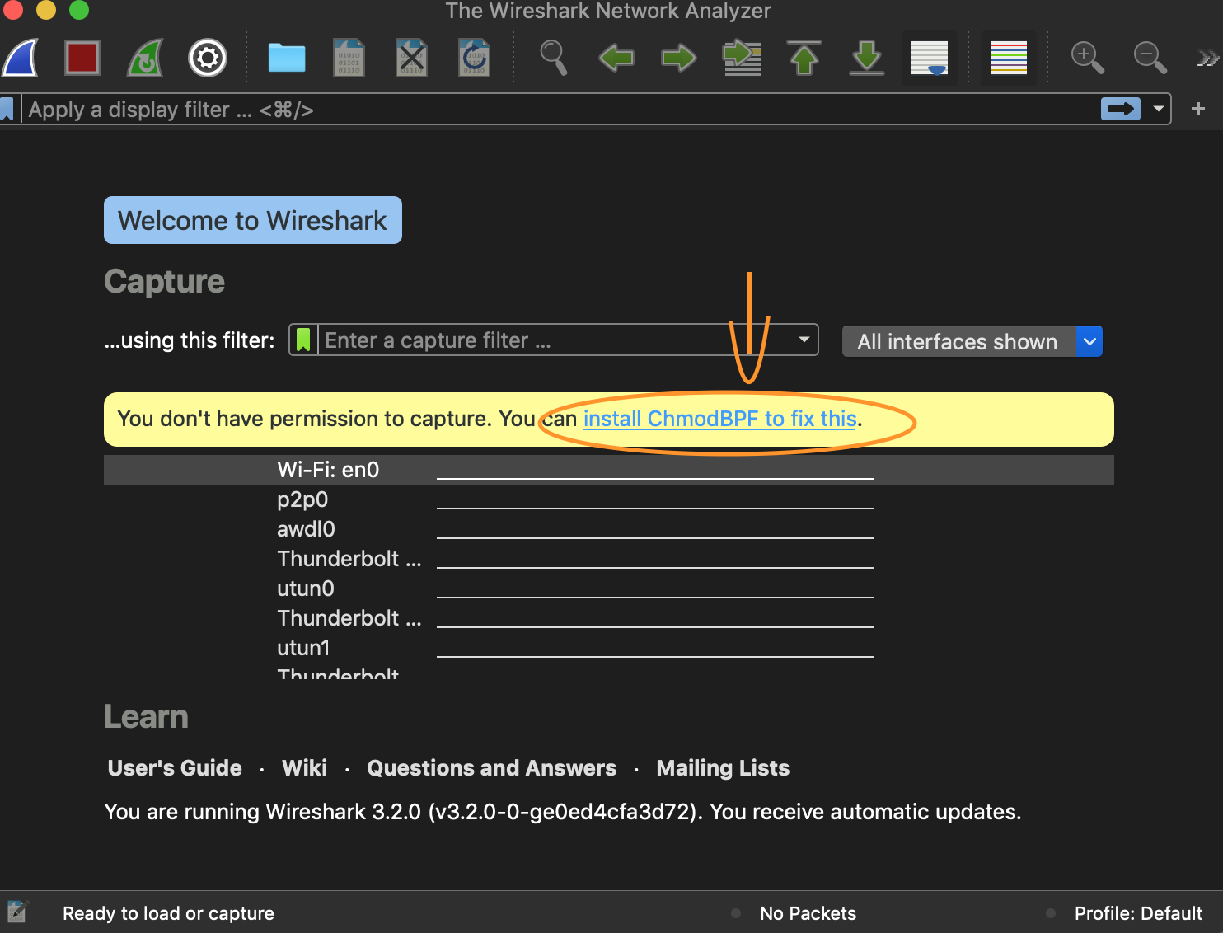

**Complete the installation**

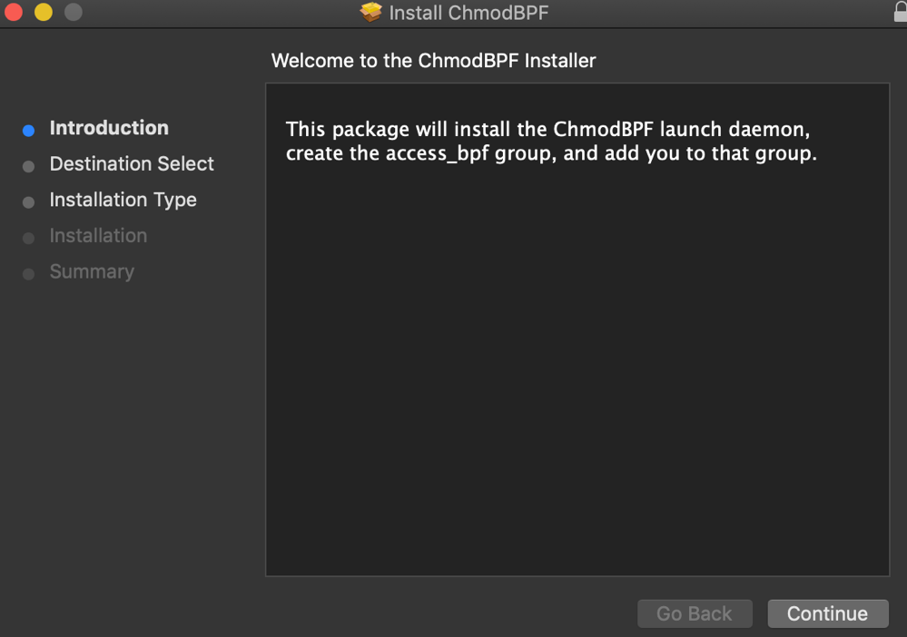

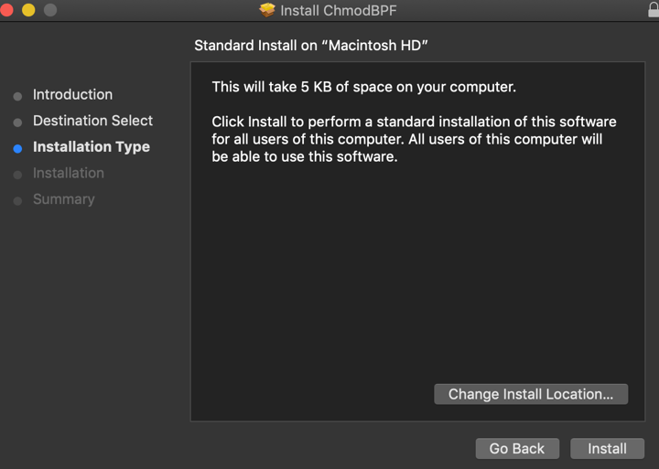

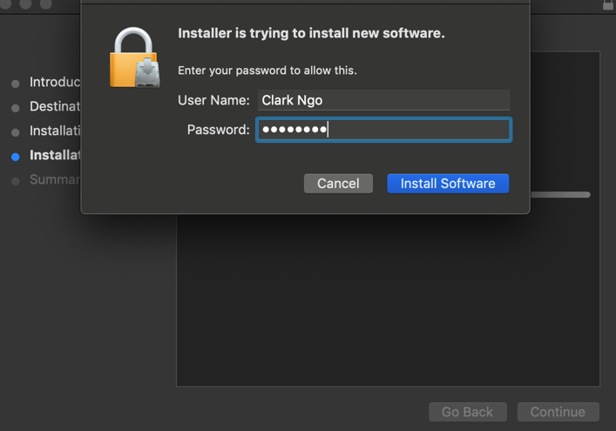

**The Wireshark App**

